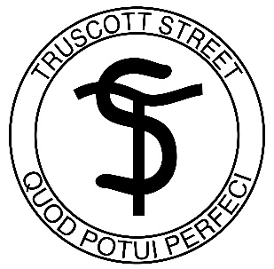

Positive Behaviour for Learning
Statement of Purpose – Student Code of Behaviour

At Truscott Street Public School we want to foster a positive and inclusive school environment that promotes respectful, responsible and safe students.
